ESPRESSO for COCO

Screenshot of Espresso run from the Command Window.

The input file, in the same directory, was inc3.txt .

Espresso created the output file out_inc3.txt in the same directory.

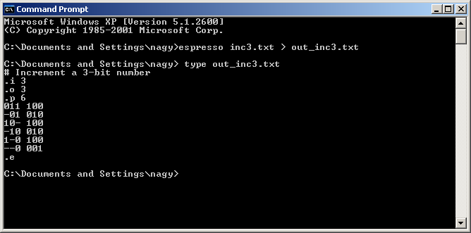
The espresso_coco file contains the program, or you can download it from the site
shown on the intro.html page in this LMS folder.

